Purpose
This report describes a research effort led by DDG UX Research (UXR) and Alexa Excellence, in partnership with Alexa Economics. Prior to the release of Doppler in 2014, internal research generated recommendations for response latencies for various intents; however, this guidance is now likely outdated, as customer expectations for acceptable latency are known to change over time. Understanding perceptions of latency will allow teams to set performance requirements for Alexa to ensure an excellent customer experience. Reducing response latency is also necessary for Echo devices to outperform image competitors, with internal benchmarking in Q4 2020 finding that Echo Dot/Show was slower than Nest Mini/Hub in a majority of evaluated intents. Additionally, Negative Value Action (NVA) modeling has shown that reducing latency will lead to substantial gains in downstream engagement and customer spending. The present research establishes data-supported thresholds for response latency and complements NVA modeling by showing that customers are sensitive to differences in response latency.

Executive Summary
Customer perceptions of verbal response latency were measured for twelve high-priority intents. Results show that customer expectations for acceptable latency depend on the type of intent. Data-supported latency thresholds are proposed for each intent type evaluated in this research. Intents include: PlayMusic, PlayStation, TurnOnAppliance, TurnOffAppliance, Q&A, Call, and AddtoList. If proposed thresholds for these intents would have been met in Jan 2020, NVA modeling by the Alexa Economics team estimates 50.3B additional dialogs and $1.7B in incremental OPS would have been realized from Jan 2020 to Mar 2021. Proposed latency thresholds, a description of NVA modeling, and full recommendations are described below.
Methodology
Thirty participants completed 72 tasks that varied in response latency and intent type, for a total of 2,160 tasks across all participants. The FAQ section provides a discussion on sample size, statistical confidence, and considerations when generalizing findings to Alexa customers. The specific intent types were selected following consultation with the Alexa Excellence Latency team to ensure that high priority intents and a variety of domains were represented. To manipulate latency, custom software described in Appendix E allowed the researcher to manipulate Alexa’s verbal response latency following utterances from each research participant. The response latencies examined in this research were: 500, 1000, 1500, 2000, 2500, & 3000 milliseconds. These values were selected to represent the range of latencies experienced by our customers in the USA. For example, 1500ms and 3000ms approximate the present 50th and 95th percentiles of response latency, averaged across all 1P devices and intent types.
We also included latencies that are Northstar goals for Alexa Excellence (1000ms) and latencies that, on average, approximate human-to-human multiturn interaction (~ 500 ms). After the device detected a participant’s utterance, Alexa provided a response that varied in latency. After receiving a response, participants gave a subjective rating for perceived latency, using the following scale: Too Slow, Somewhat Slow, or Not Slow. This rating scale is further described in the FAQ section. Finally, participants provided qualitative feedback on differences in latency expectations for the different intent types.
Limitations
First, many factors influence human perception of latency beyond objective response time, including visual affordances (e.g., LED ring), auditory affordances (e.g., earcons), and prior experience. However, this research solely focused on perceptions of verbal response latency, which we defined as the time interval from the completion of a participant’s utterance until the beginning of Alexa’s verbal response. We recommend additional research to explore the interactive effects of other factors on perceptions of latency. Next, this research took place in a controlled laboratory, not the natural environment of a customer’s home, which may affect auditory perception and expectations for acceptable latency. Also, due to limits on session time and user fatigue, not every latency occurred for every utterance. However, we anticipate these last two limitations did not affect research findings.
The full task list with associated latencies can be found in Appendix B.
General Findings
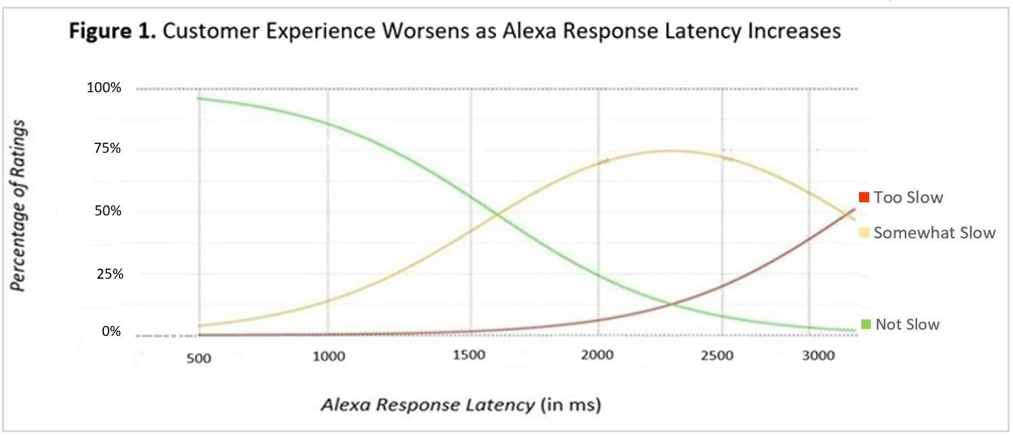
Figure 1 displays the percentage of user ratings averaged across all intent types and response latencies in our study. Results for all evaluated intent types with associated margins of error are found in Appendix A.

When averaging across all intent types, user satisfaction steadily decreases as response latencies increase. The most significant drop-off in satisfaction occurs for response latencies slower than 1000ms, with the proportion of ‘Somewhat Slow’ ratings nearly tripling as responses latencies increase to 1500ms. This finding is concerning, as the present median value of response latencies averaged across all device types and intent types in the USA is 1600ms. Therefore, we estimate at least 41% of Alexa’s responses as of March 2021 will be perceived as at least ‘somewhat slow’ by our customers in the USA. As a reference of current latency experienced by our customers, this tracking dashboard displays latency values by percentile for the latest generation Echo Dot (i.e., Brownie). While this finding warrants the reduction of latency for all intent types, limitations in technical and financial resources require more precise goals. By focusing on intent-specific goals, we can identify areas to prioritize, as we continue to broadly reduce latency across all intents and device types. In general, we have identified that perceptions of response latency depend on the task intent of the user.
Response Latency Guidelines
Based on the findings from the present research, we recommend adopting two latency thresholds for each intent type:
a High Satisfaction Threshold (HST) and an Acceptable Satisfaction Threshold (AST). The HST threshold is the response latency for a given intent that results in >70% of customers rating it not slow and <5% rating it too slow. The AST threshold is the response latency that results in >50% of customers rating it not slow and <15% rating it too slow. For a detailed explanation and rationale of these thresholds and how these latencies compare to image competitors, see FAQ #3. The recommended response thresholds for each intent type are provided in Table 2 below along with current US-based Trimmed Mean response latencies (‘TM95’; averages excluding the slowest 5%) for the latest-generation Echo Dot (i.e., Brownie). Three of the evaluated intent types already fall under the acceptable threshold; however, all evaluated intent types fail to meet the thresholds for achieving high satisfaction. Intent types are ordered by percentage differences between High Satisfaction thresholds and present TM95 latency.

Table 2. Response latency guidelines by intent type
Intent Type | Brownie TM95 Latency (3/21) | Threshold for achieving  Acceptable Satisfaction | % Diff | Threshold for achieving  High Satisfaction | % Diff
TurnOffAppliance | 1.9 sec | 1.0 sec | (-47.3%) | 500 ms | (-73.7%)
TurnOnAppliance | 1.8 sec | 1.0 sec | (-44.4%) | 500 ms | (-72.2%)
Q&A | 1.8 sec | 1.0 sec | (-44.4%) | 500 ms *** | (-72.2%)
AddtoList | 1.3 sec | 1.0 sec | (-23.1%) | 500 ms | (-61.5%)
WhatTime | 1.1 sec | 1.0 sec | (-9.1%) | 500 ms | (-54.5%)
Call Intent | 1.9 sec | 1.5 sec | (-21.1%) | 1.0 sec | (-47.4%)
PlayMusic | 1.7 sec | 1.5 sec | (-11.7%) | 1.0 sec | (-41.2%)
PlayStation | 1.7 sec | 1.5 sec | (-11.7%) | 1.0 sec | (-41.2%)
All Intents** | 1.6 sec | 1.5 sec | (-6.3%) | 1.0 sec | (-37.5%)
LaunchApp | 1.5 sec | 1.5 sec | (=) | 1.0 sec | (-33.3%)
GetWeather | 1.2 sec | 1.5 sec | (+25%) | 1.0 sec | (-16.7%)
SetNotification | 1.2 sec | 1.5 sec | (+25%) | 1.0 sec | (-16.7%)
Error Response | **** | 1.5 sec | - | 1.0 sec | -
Notes: *See Lines 56-59 for definitions of Acceptable & High Satisfaction
**Proposed thresholds for TM95 response latency averaged across all intent types
***For Q&A intent, we recommend that responses are no faster than 500ms, as this is faster than human-human conversation and may be unsettling to customers
****Proposed thresholds for Alexa responding that she did not understand the utterance or cannot complete the task

Qualitative Feedback: Why did two buckets of response thresholds emerge?
Throughout research sessions, participants provided unstructured qualitative feedback on differences in expectations that they had for intent types. In general, perceptions of response latency are heavily influenced by the intent and domain type. Two common themes emerged that were expressed by more than 50% of our research sample and generally align with ratings of latency for the different evaluated intent types. First, smart home and HHO intents (e.g., TurnOn/Off, WhatTime, AddtoList, Playback Controls) that have real-world analogues (e.g., light switches, wristwatches, notepads, remote controls) are expected to be nearly instantaneous following the completion of their utterance. Several participants mentioned that if the device does not complete these tasks faster than a physical analogue, then it limits the utility of the smart device. A second theme is that participants tend to be more forgiving of slower latency for tasks that they believe to require information retrieval (e.g., asking for weather, asking for a recipe, searching for a song). A preliminary hypothesis of why these differences in expectation exist, appears to depend on if a task is focused on information retrieval vs. execution of a command. However, the present findings due not fully align with this hypothesis as the Q&A intent (i.e., an information retrieval task) is expected to be as fast as device commands. We recommend further research to examine if current and future intent types can be reliably partitioned into buckets.
Prioritizing Latency Reduction Goals by Predicted Impacts on Downstream Engagement & Customer Spending
In 2020, the Alexa Economics team introduced the Alexa Negative Value Action (NVA) model which measures long-term downstream customer engagement change after a customer had ‘defective’ experiences with Alexa (e.g., slow response latency).
The model also measures long term impact on customer spending (OPS). NVA modeling provides useful prioritization information that can be applied to the present research, by partitioning engagement by intent type. For each customer engaged in a given intent type, Alexa Economics collects data on the number of ‘successful’ responses (e.g. latencies faster than 30th percentile) and the number of ‘defective responses’ (e.g., latencies slower than 30th percentile) and places the two groups into separate buckets.
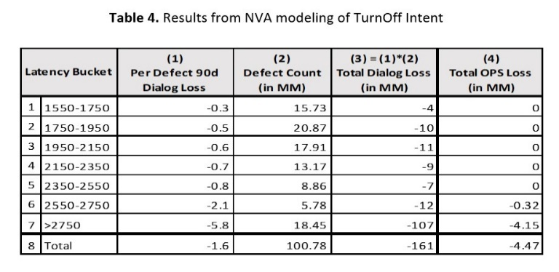
Next, by identifying and matching customers who share similar profile characteristics (e.g., Prime status, device type, etc.) and similar engagement characteristics (e.g., historical engagement, frequency and recency of engagement), the NVA model compares their downstream engagement and attributes engagement loss to defective response latencies, for a given intent type.
For example, NVA modeling was used in January 2020 to look at TurnOffAppliance intent using 8 latency buckets at 200ms increments. Results from modeling for TurnOffAppliance Intent are shown in Table 4.
On average, NVA modeling found that customer’s experiencing a TurnOffAppliance Intent with latencies slower than 2750ms will have 6 fewer dialogs (column 1) across all Alexa domains in the next 90 days, compared to similar customers who had a successful response (i.e., <1550ms), on the same day with the same type of device. For the month of January 2020, defective response latencies occurred following nearly 101MM utterances (column 2), leading to a total of 161MM lost dialogs (column 3) over the following 90 days.
Lost dialogs are an index of how many additional customer interactions with Alexa would have occurred over a specified interval of time if not for a prior defective experience. In general, for the month of January 2020, we would have had 161MM more dialogs over the subsequent 90 days if all response latencies for TurnOff intent were to have been faster than 1550ms. Using the Alexa Economic Value of Engagement (EVE) Model, this translates to $4.47MM incremental OPS spending in retail over these 90 days. The Alexa Economics team has conducted NVA modeling on the findings of the present response latency research. Please note that not all evaluated intent types could be modeled due to insufficient data. Table 5 displays our prioritized latency recommendations based on the magnitude of predicted increases in engagement and incremental OPS.
Table 5. Prioritized Latency Reduction Goals based on Alexa NVA Modeling
Intent Type | TM95 Latencies on Brownie in USA  as of 03/21 | Minimum Acceptable  Satisfaction  Threshold | Additional Dialogs as Acceptable Satisfaction  is Achieved (in MM) | Additional OPS as  Acceptable Satisfaction  is Achieved (in MM)
PlayMusic | 1.7 sec | 1.5 sec | 21,545 | $447
TurnOffAppliance | 1.9 sec | 1.0 sec | 11,567 | $411
TurnOnAppliance | 1.8 sec | 1.0 sec | 7,264 | $338
PlayStation | 1.7 sec | 1.5 sec | 5,730 | $84
Q&A | 1.8 sec | 1.0 sec | 3,227 | $9
AddtoList | 1.3 sec | 1.0 sec | 783 | $430
CallIntent | 1.9 sec | 1.5 sec | 273 | $3
Predicted Increases in Dialogs & OPS as Min Acceptable is Achieved = |  |  | + 50,389 | + 1,722

As shown in the results from NVA modeling, if we were able to reduce Alexa response latency from the present TM95 values to our acceptable satisfaction thresholds for the following high-priority intent types—PlayMusic, PlayStation, Q&A, CallIntent, AddtoList, TurnOn and Turn Off—our partners from Alexa Economics estimate that an additional 50.3 billion dialogs and $1.7 billion in incremental OPS would have been realized over the period from Jan 2020 to March 2021. To maximize the largest gains in engagement and OPS, we recommend prioritizing latency reductions for PlayMusic, TurnOn, and TurnOff Intents. We are currently unable to leverage NVA modeling to predict how engagement and OPS will be affected as we reduce latency below our thresholds for high satisfaction response latency. Specifically, as NVA modeling compares ‘defective’ responses (slower than 30th percentile) against successful responses (faster than 30th percentile), our thresholds for high satisfaction latencies are faster than present TP30 and we do not have sufficient data to accurately model these reductions. However, we are confident that engagement and OPS will continue to increase as we broadly reduce response latency for all intent types.
Next Steps
The present research has established data-supported thresholds for both high satisfaction and minimum acceptable response latencies for Alexa. To continue improving customer experience when interacting with Alexa, we recommend additional research to:
- Identify generalizable characteristics of intents that predict customer expectation for response latency
- Investigate the effects of visual (e.g., voice chrome, LED ring) and auditory (e.g., earcons) affordances on perception of latency
- Investigate and model the effects of touch latency on customer experience and downstream engagement
- Investigate effects of latency in mobile contexts (e.g., auto, wearables)

FAQs
1) How well do Echo devices perform relative to image competitors during benchmarking?
In Q4 2020, Echo Dot was slower than Nest Mini in 7/10 intents in US, 6/7 in UK, 7/10 intents in JP, 7/9 intents in DE. Echo Show was slower than Google Nest Hub in 5/10 intents in US and 6/9 in DE. In US, Alexa headless device is slower than Google by 540-610 ms in Notifications, by 610/650 ms in PlayMusic/PlayStation, and by 840 ms in QA. The US Multimodal device is slower by 310 ms in Notifications and 840 ms in PlayMusic. The full benchmarking report can be found here. These differences in latency are likely perceptible by customers, if they use both Amazon and Google devices.
2) Why did we use the term ‘Alexa Response Latency’ instead of ‘User Perceived Latency’?
While the term User Perceived Latency (UPL) has been used by Amazon to describe the time interval from the completion of an utterance until the response from Alexa, the continued use of this term is not recommended. Specifically, using UPL as an internal metric perpetuates an incorrect assumption that a user’s perception of latency is identical to the true objective latency of the device. Therefore, we recommend using the term Alexa Response Latency (i.e., the objective time interval), as opposed to UPL (i.e., the subjective perception of Alexa’s response latency).
3) Why did we have users provide ratings of Too Slow, Somewhat Slow, or Not Slow?
Customers do not think about response latency in terms of how fast Alexa responds. Response latency only becomes noticeable when it is slow enough to cause dissatisfaction. Therefore, this rating scale allowed for us to establish high standards for response latency by identifying the thresholds that customers consider slow. By establishing latency reduction goals that minimize the likelihood that customers will find a response to be somewhat or too slow, we will enhance the customer experience when interacting with Alexa.
4) Why did we use the 3-point Rating Scale?
There are two main advantages of 3-pt scales over 5-pt or 7-pt options: improved accuracy of measurement and improved clarity of interpretation of data. A detailed description of the benefits of 3-pt scales can be found in this wiki.
5) How did we generate the thresholds for High Satisfaction and Acceptable Satisfaction response latencies?
We defined High Satisfaction latencies as responses that will, on average, result in >70% of customers stating a response to a certain intent is not slow and <5% finding it too slow. Also, we defined Acceptable Satisfaction latencies as responses that result, on average, in >50% of customers stating a response latency is not slow and <15% finding it too slow. These thresholds are informed by experience and high judgment. The application of similar response scales with Amazon customers has shown that subjective ratings in excess of 70% ‘very good’ and less than 5% ‘not good enough’ are achievable (refer to Prime Video or FireTV CX Quality Programs, both of which generate scores in this range for ratings of video playback quality). This establishes a high bar for high satisfaction latencies. Meanwhile, our acceptable satisfaction thresholds for latency still result in a majority of customers finding a response to a given customer intent as “not slow”. These thresholds represent stretch goals that will increase customer satisfaction and are realistic goals for Alexa Engineering teams over the next couple of years. While increasingly faster responses for most intent types are worthwhile goals, we acknowledge that limitations in technical and financial resources will require strategic prioritization based on intent types.

6) Can we generalize the findings from this research sample to tens of millions of customers?
The confidence interval for this study is 90% with a margin of error ranging from 5-15% depending on intent type (see appendix A for additional detail). In plain terms, we can be highly confident that moderate-to-large differences in customer ratings in this study will generalize to our broader customer base. Achieving high confidence in small differences can be achieved by testing more users.
An n of 30 balances High Standards, Bias for Action, and Frugality and was guided by the Central Limit Theorem (Kwak & Kim, 2017).
If we want to further reduce the margins of error to 5% at 90% confidence for each intent type we will need to recruit and run ~300 participants; however, this would cost an additional $400-500k and would require 6-12 months of time. We believe that these funds and this time can be more effectively spent on other research.
7) Why was this research necessary if we already have NVA modeling?
This research provides a new understanding of response latency thresholds that customers find to be slow. Continued research will allow us to better understand expectations of latency based on intent type, which can estimate performance requirements for new intents before launch. Additionally, this research extends and supports the findings of NVA modeling. Due to the very large estimates for increased engagement and OPS, the validity of the model is sometimes questioned. However, our research has found that customers are indeed sensitive to differences in response latency which can impact future engagement with Alexa.

Appendix A: Response Latency Ratings and Margins of Error for All Intent Types
The following figures display the proportions of user ratings for each response latency by intent type. Additionally, tables are provided for each intent type and display the specific proportion values and margins of error associated with 90% confidence intervals be found within parentheses.
All Intent Types

Response Latency | Too Slow | Somewhat Slow | Not Slow
500 ms | 0.1 (0.0, 0.2) | 3.9 (0.7, 7.0) | 96.1 (92.8, 99.3)
1000 ms | 0.3 (0.1, 0.6) | 13.9 (4.4, 23.4) | 85.8 (76.0, 95.5)
1500 ms | 1.6 (0.6, 2.6) | 42.3 (29.0, 55.7) | 56.1 (41.8, 70.3)
2000 ms | 6.1 (2.5, 9.7) | 69.7 (61.6, 77.7) | 24.2 (13.0, 35.5)
2500 ms | 20.0 (9.1, 30.8) | 72.3 (65.9. 78.8) | 7.7 (2.8,12.5)
3000 ms | 39.0 (23.4, 54.7) | 57.8 (44.1, 71.6) | 3.1 (1.1, 5.2)

PlayMusic Intent

Response Latency (ms) | Too Slow | Somewhat Slow | Not Slow
3000 | 0.33 (.14) | 0.60 (.15) | 0.07 (.07)
2500 | 0.30 (.14) | 0.53 (.15) | 0.17 (.11)
2000 | 0.13 (.10) | 0.50 (.15) | 0.37 (.14)
1500 | 0 | 0.40 (.15) | 0.60 (.15)
1000 | 0 | 0.13 (.10) | 0.87 (.10)
500 | 0 | 0.03 (.07) | 0.97 (.05)

PlayStation Intent

Response Latency (ms) | Too Slow | Somewhat Slow | Not Slow
3000 | 0.43 (.15) | 0.47 (.15) | 0.10 (.09)
2500 | 0.30 (.14) | 0.57 (.15) | 0.13 (.10)
2000 | 0.20 (.12) | 0.50 (.15) | 0.27 (.13)
1500 | 0.03 (.05) | 0.33 (.14) | 0.63 (.14)
1000 | 0 | 0.21 (.12) | 0.79 (.12)
500 | 0 | 0.07 (.07) | 0.93 (.07)

Q&A Intent

Response Latency (ms) | Too Slow | Somewhat Slow | Not Slow
3000 | 0.41 (.15) | 0.45 (.15) | 0.14 (.10)
2500 | 0.32 (.14) | 0.50 (.15) | 0.18 (.12)
2000 | 0.14 (.10) | 0.55 (.15) | 0.27 (.13)
1500 | 0.13 (.10) | 0.6 (.15) | 0.31 (.14)
1000 | 0.03 (.05) | 0.4 (.15) | 0.57 (.15)
500 | 0 | 0.30 (.14) | 0.70 (.14)

Turn ON Appliance Intent

Response Latency (ms) | Too Slow | Somewhat Slow | Not Slow
3000 | 0.50 (.15) | 0.37 (.14) | 0.13 (.10)
2500 | 0.37 (.14) | 0.40 (.15) | 0.23 (.13)
2000 | 0.17 (.11) | 0.50 (.15) | 0.33 (.14)
1500 | 0.03 (.05) | 0.50 (.15) | 0.47 (.15)
1000 | 0 | 0.33 (.14) | 0.67 (.14)
500 | 0 | 0.03 (.05) | 0.97 (.05)

Turn OFF Appliance Intent

Response Latency (ms) | Too Slow | Somewhat Slow | Not Slow
3000 | 0.52 (.15) | 0.34 (.14) | 0.14 (.10)
2500 | 0.45 (.15) | 0.35 (.14) | 0.21 (.12)
2000 | 0.10 (.09) | 0.57 (.15) | 0.33 (.14)
1500 | 0 | 0.38 (.15) | 0.62 (.15)
1000 | 0 | 0.25 (.13) | 0.75 (.13)
500 | 0 | 0.03 (.05) | 0.97 (.05)

SetNotification Intent

Response Latency (ms) | Too Slow | Somewhat Slow | Not Slow
3000 | 0.60 (.15) | 0.33 (.14) | 0.07 (.07)
2500 | 0.31 (.14) | 0.55 (.15) | 0.14 (.10)
2000 | 0.10 (.09) | 0.77 (.13) | 0.13 (.10)
1500 | 0 | 0.40 (.15) | 0.60 (.15)
1000 | 0 | 0.10 (.09) | 0.90 (.09)
500 | 0 | 0.07 (.07) | 0.93 (.08)

WhatTime Intent

Response Latency (ms) | Too Slow | Somewhat Slow | Not Slow
3000 | 0.43 (.15) | 0.43 (.15) | 0.13 (.10)
2500 | 0.33 (.14) | 0.47 (.15) | 0.2 (.12)
2000 | 0.14 (.10) | 0.59 (.15) | 0.28 (.13)
1500 | 0.03 (.05) | 0.43 (.15) | 0.53 (.15)
1000 | 0.10 (.09) | 0.20 (.12) | 0.70 (.14)
500 | 0.03 (.05) | 0.17 (.11) | 0.79 (.12)

GetWeather Intent

Response Latency (ms) | Too Slow | Somewhat Slow | Not Slow
3000 | 0.40 (.15) | 0.47 (.15) | 0.13 (.10)
2500 | 0.37 (.14) | 0.47 (.15) | 0.17 (.11)
2000 | 0.20 (.12) | 0.43 (.15) | 0.37 (.14)
1500 | 0 | 0.43 (.15) | 0.57 (.15)
1000 | 0 | 0.33 (.14) | 0.67 (.14)
500 | 0 | 0.04 (.05) | 0.96 (.05)
Call Intent

Response Latency (ms) | Too Slow | Somewhat Slow | Not Slow
3000 | 0.47 (.15) | 0.40 (.15) | 0.13 (.10)
2500 | 0.33 (.14) | 0.47 (.15) | 0.20 (.12)
2000 | 0.13 (.10) | 0.53 (.15) | 0.33 (.15)
1500 | 0.07 (.07) | 0.43 (.15) | 0.50 (.15)
1000 | 0 | 0.23 (.13) | 0.77 (.13)
500 | 0 | 0.03 (.05) | 0.97 (.05)

Add To List Intent

Response Latency (ms) | Too Slow | Somewhat Slow | Not Slow
3000 | 0.47 (.15) | 0.43 (.15) | 0.10 (.09)
2500 | 0.21 (.12) | 0.66 (.14) | 0.14 (.10)
2000 | 0.13 (.10) | 0.53 (.15) | 0.33 (.14)
1500 | 0.07 (.07) | 0.34 (.14) | 0.59 (.15)
1000 | 0 | 0.33 (.14) | 0.67 (.14)
500 | 0 | 0.07 (.07) | 0.93 (.07)

LaunchApp Intent

Response Latency (ms) | Too Slow | Somewhat Slow | Not Slow
3000 | 0.47 (.15) | 0.40 (.15) | 0.13 (.10)
2500 | 0.23 (.13) | 0.53 (.15) | 0.23 (.13)
2000 | 0.03 (.05) | 0.57 (.15) | 0.40 (.15)
1500 | 0 | 0.41 (.15) | 0.59 (.15)
1000 | 0 | 0.17 (.11) | 0.83 (.11)
500 | 0 | 0.03 (.05) | 0.97 (.05)

Error State Response

Response Latency (ms) | Too Slow | Somewhat Slow | Not Slow
3000 | 0.43 (.15) | 0.43 (.15) | 0.13 (.10)
2500 | 0.17 (.11) | 0.72 (.13) | 0.10 (.09)
2000 | 0.14 (.10) | 0.55 (.15) | 0.31 (.14)
1500 | 0.14 (.10) | 0.41 (.15) | 0.45 (.15)
1000 | 0.07 (.07) | 0.33 (.14) | 0.60 (.15)
500 | 0.03 (.05) | 0.17 (.11) | 0.79 (.12)

Appendix B. Utterance & Response Pairs

Intent Type | User Utterance | Alexa Response | Verbal Response Latencies in ms
PlayMusic | Alexa, Play country music on Amazon music | Ok, playing country music on Amazon music | 500, 1000, 1500
 | Alexa, Play Taylor Swift songs | Ok, playing Taylor swift on Amazon music | 2000, 2500, 3000
PlayStation | Alexa, Play Bon Jovi station | Ok, playing Bon Jovi on Amazon music | 500, 1000, 1500
 | Alexa, Play Lady Gaga station | Ok, playing Lady Gaga on Amazon music | 2000, 2500, 3000
Q&A | Alexa, When is memorial day? | Memorial day is on Monday, May 31st | 500, 1000, 1500
 | Alexa, How tall is Mt Everest? | Mt Everest is 29,029 feet | 2000, 2500, 3000
GetWeather | Alexa, What is the weather in Seattle? | Currently in Seattle, it is 65 degrees with light rain | 500, 1000, 1500
 | Alexa, What is the weather in New York? | Currently in New York, it is 45 degrees with clouds | 2000, 2500, 3000
SetNotification | Alexa, Set an alarm for 6 am | OK, alarm is set for six a.m. | 500, 1000, 1500
 | Alexa, Set a timer for two hours | OK, timer is set for two hours | 2000, 2500, 3000
WhatTime | Alexa, What time is it in Melbourne? | In Melbourne, it is nine-thirty p.m. | 500, 1000, 1500
 | Alexa, What time is it in Tokyo? | In Tokyo, it is eight-fifteen a.m. | 2000, 2500, 3000
LaunchApp | Alexa, Play the Jeopardy skill | OK, starting Jeopardy skill | 500, 1000, 1500
 | Alexa, Play the Sleep Sounds skill | OK, starting sleep sounds skill | 2000, 2500, 3000
CallIntent | Alexa, Call Brad’s Echo Device | OK, calling Brad | 500, 1000, 1500
 | Alexa, Call Steve’s Echo Device | OK, calling Steve | 2000, 2500, 3000
AddtoList | Alexa, Add milk to my shopping list | Ok, I’ve added milk to your list | 500, 1000, 1500
 | Alexa, Add Kind Bars to my shopping list | OK, Kind bars added to your list | 2000, 2500, 3000
TurnOnAppliance | Alexa, Turn on my kitchen light | Ok | 500, 1000, 1500
 | Alexa, Turn on the TV | Ok | 2000, 2500, 3000
TurnOffAppliance | Alexa, Turn off my kitchen light | OK | 500, 1000, 1500
 | Alexa, Turn off the TV | Ok | 2000, 2500, 3000
Error Response | Alexa, Who won the Super Pool? | Sorry, I didn’t get that | 500, 1000, 1500
 | Alexa, Can you do a backflip? | Sorry, I didn’t get that | 2000, 2500, 3000

Appendix D: Session Flow & Discussion Guide

** (Note to moderator: ensure cameras are set up as specified, and recording has started) **
I. Background Questions (5 min)
- Thanks for participating today! You’re here today to answer some questions and complete a series of tasks with help from a voice assistant
- First, please tell me a little bit about yourself, your age, what you do for work
II. Introduction to Tasks (5 min)
- For the next part of this session, I’ll ask you to complete certain tasks using the Alexa voice assistant.
- The tasks are shown here on this list in front of you. To complete the task, you will ask Alexa the specific question or command and after a few moments will be provided with a response from the Alexa.
- We are primarily interested in your perceptions of how fast or slow Alexa’s responses are. We will be examining several different response speeds today.
- After each task, I’ll have you provide a rating of Alexa’s response, using a scale of: Not Slow, Somewhat Slow, Too Slow
  - (Note to moderator- Provide elaboration here on the differences between these ratings)
- After you provide a rating, you will then move on to the next task in the list
- After some tasks, I may ask you to discuss your reactions and you will be encouraged to be as candid as possible in describing what you find to be good or bad about Alexa’s response and how the type of question or command may have affected your rating.
  - (Note to moderator- Provide elaboration here if participant appears confused)
- Please note that some of the responses may not give you an accurate answer (e.g., the time or the weather). Please ignore this and simply provide a rating of the speed of Alexa’s response.
- Again, after each tasks, I’ll have you **Confirm that these task instructions make sense. Provide additional clarity here, if needed.**
- **Complete 3 practice tasks** Ensure participant understands testing format**

Appendix C. Current Latency Percentile Groups in USA for Brownie on Measured Intent Types (on 3/8/21)
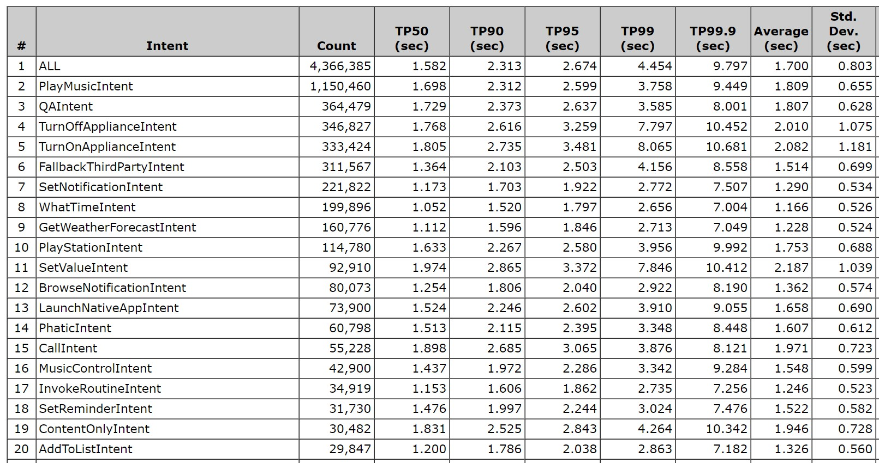
Appendix E: Manipulating Latency via WOZ Dashboard
At present, we do not have the capability to actually reduce latency on customers’ personal devices. Thus, for the purposes of this study, the design technology team in DDG developed a prototype Bishop device with a custom userdebug build to perform wake word detection and utterance termination. By connecting this Bishop device to a computer via USB, we used a CSM Node shark function to identify the end of a user’s utterance, which started the response latency timer. As shown in the screenshot below, a WOZ latency dashboard allowed the researcher to specify a response latency for each utterance that the test participant will say.

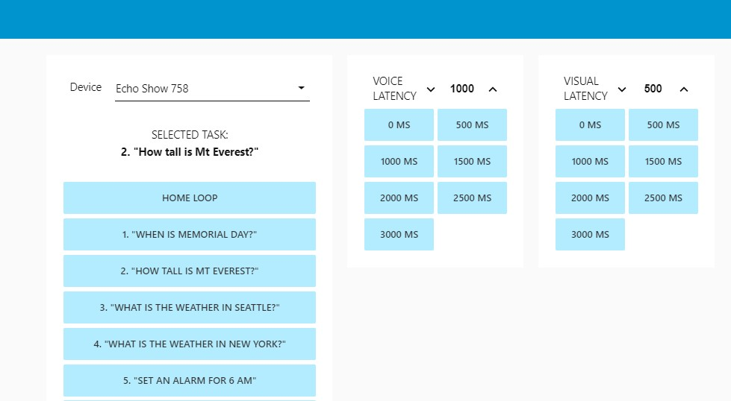

Levinson & Torreira, 2015 (see report here)

